EMA(Model Exponential Moving Average)

we use it for reducing oscillation and improving stabilization and generalization

why????
- during training, weight keep updated! so we got an idea!
ok! we trust weight, but also trust the past weights
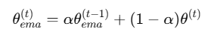

alpha is called to “decay”, which means how much we trust the past model
for example, if we set 0.999 to decay, it means we will keep 99.9% of past weight,and only 0.001% we will update weight with current one.

Benefit
- reduce noise and boost stabilization training!
- it gives higher performance even relatively higher learning rate

Tip
- we can use EMA from gpu to save GPU resources, but which means it is disable to valid of EMA weights. so it needs to do manually validation in a separate process
- ema model should be independent from original model(deepcopy essential)

Code example(timm)
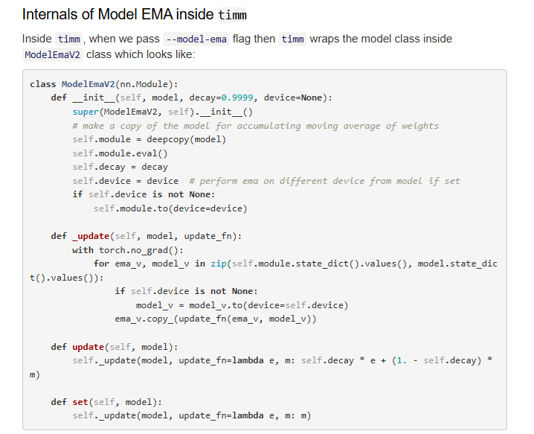

there are two mode
- EMA : decay * e + (1- decay) * m
- Hard copy : m(use it after finishing first training or warm up)

ema_v.copy_ : in-place update, keep reference, no reassign memory

